Push Up Test
(chin must touch eraser)

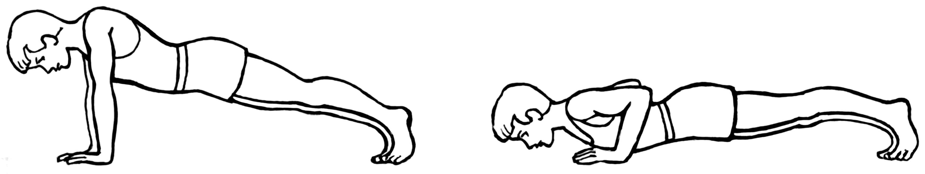

 | 6th Grade | 7th Grade | 8th Grade
A-100% | 20 or more | 25 or more | 30 or more
A-95% | 18-19 | 21-24 | 28-29
A-90% | 15-17 | 18-20 | 25-27
B-85% | 13-14 | 15-17 | 21-24
B-80% | 11-12 | 14 | 15-20
C-75% | 9-10 | 11-13 | 11-14
C-70% | 7-8 | 7-10 | 7-10
D-65% | 5-6 | 5-6 | 5-6
D-60% | 3-4 | 3-4 | 3-4
F-55% | 1-2 | 1-2 | 1-2
F-50% | 0 with effort | 0 with effort | 0 with effort
F-0% | No Effort | No Effort | No Effort

